Offcial Website: http://kitchenknock.com.au/  Service Hotline:02-96480221  Kitchen Knock Pty Ltd (Supervised)  Address: Building E, 290 Parramatta Road, Auburn,  NSW, Australia 2144  Manufacturer: Foshan Chunmei Electrical Appliances Co., Ltd  Address: Factory Building No.2, No.1 Longhui Road, Longyong, Huanglong Village, Beijiao Town, Shunde District, Foshan City, Guangdong Province | Instructions for use of Electric Milk Steamer
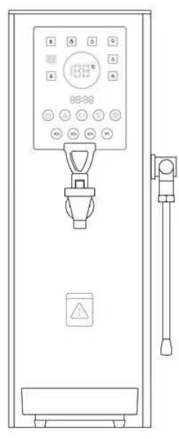
A heart high code
 | Please read this instruction carefully before use

■ The operation diagram
◆Steam
◆Milk foam
◆Infused tea
◆Heating

◆ Boiling

1


■ Daily cleaning, sewage discharge and maintenance:
Remain cleaning and good maintenance help keep the machine clean and reduce the probability of malfunctions.
1. After use, unplug the power plug and disconnect the water source.
2. Wait until the water in the water tank is completely cooled. Tilt the machine body and unscrew the copper nut at the bottom of the inner tank with a wrench to drain water and sewage. After draining, tighten the copper nut.
3. If not in use for a long time, please turn off the power and water supply, drain the water in the inner tank, wipe with towel and place the machine in a dry environment.

Troubleshooting:
Fault Condition | Troubleshooting Method
No response when powered on | Check if the power is connected; ensure the power plug is properly inserted
No heating | Check if the water tank is empty; ensure the water source is turned on; check if the heating element is faulty
No steam | Check if the steam heating element is faulty
No hot water | Ensure the water source is turned on; check if the solenoid valve is faulty; check if the heating element is working
Displays E2 | Heating tank temperature sensor fault
Displays E3 | Steam heating element temperature sensor fault
Displays E5 | Low water level probe detected no water for 20 minutes
Displays E7 | Scaling or incorrect water level wiring (water present at the high level but no water at the low level, or scaling on the low water level probe)

■ Product schematic diagram

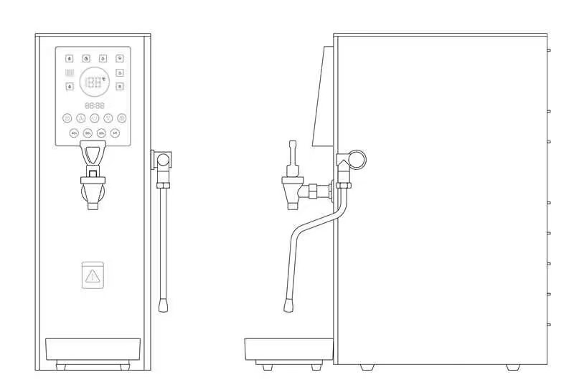

3

■ Installation Method:
1. Unpack and place the host on a stable surface
2. Connect one end of the water inlet pipe to the machine’s water inlet and the other end to the filter, and turn on the water source.
3. Plug the power cord into a dedicated 16A socket. This product operates on a 220V~/50Hz power supply. Ensure the socket has a proper ground connection to avoid the risk of electric shock.

■ Usage Method:
After connecting the power and water source, press the Power Button to start.

■ Safety Instructions:
1. After powering on, the unit will automatically refill with water. Once the water level exceeds the minimum level (E1 error is cleared), it will automatically start heating. The boiling water indicator will light up when the water temperature reaches 100 degrees Celsius.
2. Heating will automatically stop when the boiler steam pressure reaches 1.5 bar and will restart when the pressure drops below 1.0 bar, cycling in this manner.
3. Pressure safety indicator range: During normal operation, the green light will be on for a pressure range of 0~2.0 bar. If a malfunction occurs and the pressure is between 2.0~3.0 bar, the yellow light will illuminate as a warning. If the pressure exceeds 3.0 bar, the red light will turn on and an alarm will sound. In this case, please unplug the power immediately.
4. The safety pressure relief range is between 3.0~4.0 bar, ensuring safety.

■ After-Sales Warranty Service:
1.This product has one year warranty.
2.The warranty for this product is limited and does not cover responsibilities or losses beyond the product itself.
3.The warranty does not include faults caused by daily cleaning or failure to follow the instructions provided in this manual.
4.Warranty services for this product must be performed by authorized after-sales personnel or authorized dealers.
5.Accessories and consumable parts of this product are not covered under the warranty service.
6.Please keep this user manual safe and read it carefully.

 Basic Technical Parameters

Electric Milk Steamer
Model: | SRZ-20
Rated Voltage: | 240v~
Rated Frequency: | 50Hz
Rated Power: | 2KW/1.8KW
Water Inlet Pressure: | 0.2~0.5Mpa
Inner Tank Capacity: | 15L
Hot Water Output: | 35L per hour
Dimensions: | 235*540*580mm
Net Weight: | 12Kg
Product Compliance Standards: GB4706.1-2005 GB4706.36-2014

■ Circuit diagram：
